# CAPSTONE PROJECT

**NAME : JANHVI MISHRA**

**PROJECT DESIGNED BY : RELEVEL(UNACADEMY)**

# Introduction to Case

Ron and his buddies founded Foodie-Fi 🥑 and began selling monthly and annual

subscriptions, providing clients with unrestricted on-demand access to exclusive cuisine

videos from around the world.

This case study focuses on the use of subscription-style digital data to answer critical

business questions about the customer journey, payments, and business performance.



(double click on the pdf to open)

# Table Relationship

# 

# Table ‘plans’ Description

There are 5 customer plans:

**Trial** — Customers sign up for a 7-day free trial and will be automatically enrolled in the pro monthly subscription plan

unless they unsubscribe, downgrade to basic, or upgrade to an annual pro plan during the trial.

**Basic plan** — Customers have limited access and can only stream their videos with the basic package, which is only

available monthly for $9.90.

**Pro plan** — Customers on the Pro plan have no watch time limits and can download videos for oﬄine viewing. Pro plans begin at $19.90 per month or $199 for a yearly subscription.

When clients cancel their Foodie-Fi service, a Churn plan record with a null pricing is created, but their plan continues

until the end of the billing cycle.

# Table ‘plans’ Description (contd.)

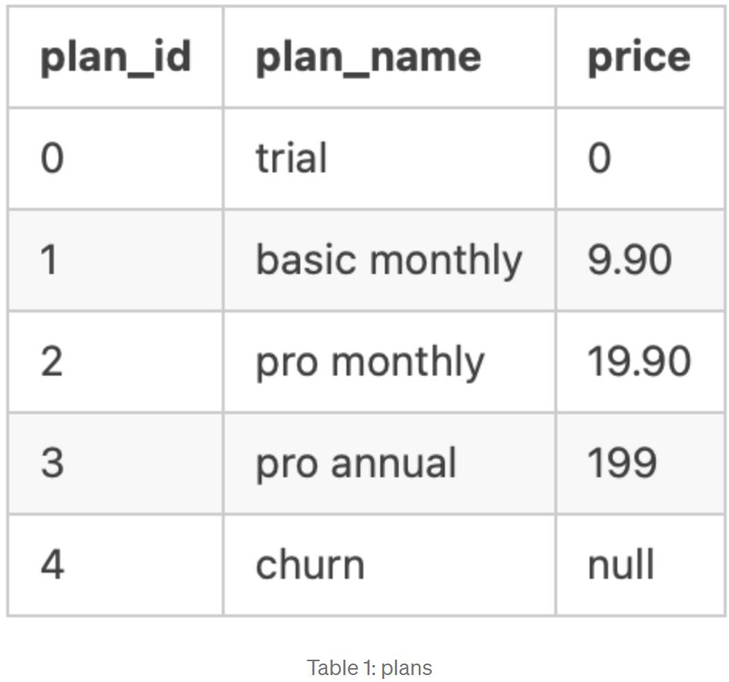

# Table ‘subscriptions’ Description

Customer subscriptions display the precise date on which their speciﬁc plan id begins.

If a customer downgrades from a pro plan or cancels their subscription — the higher program will remain in place until

the period expires — the start date in the subscriptions table will reﬂect the date the actual plan changes.

When clients upgrade their account from a basic plan to a pro or annual pro plan, the higher plan becomes active

immediately.

When customers cancel their subscription, they will retain access until the end of their current billing cycle, but the

start date will be the day they opted to quit their service.

# Table ‘subscriptions’ Description (contd.)

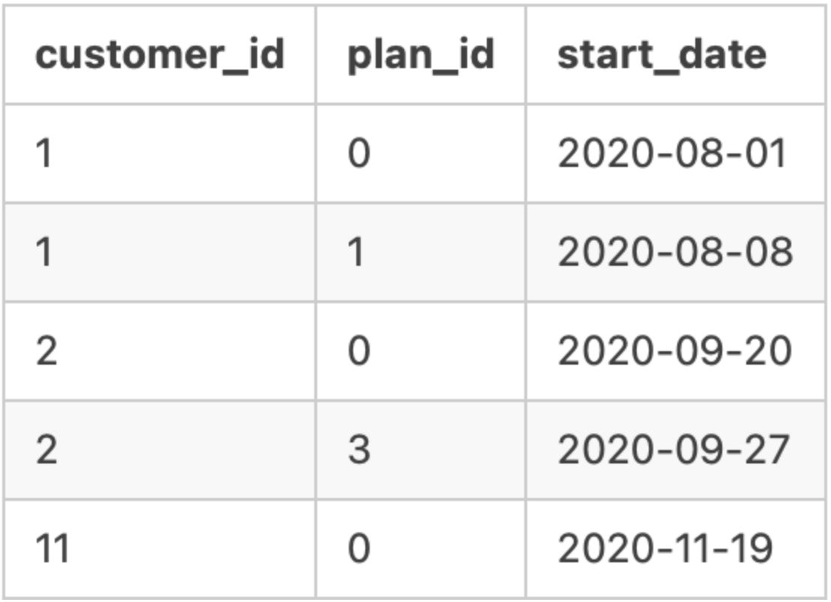

# Database

The database can be accessed here:

<https://www.db-fiddle.com/f/jbahqhW5AQwqV1RZ2xExEz/0>

**Problem Statement - 1**

**How many customers has Foodie-Fi ever had?**

Solution - 1

SELECT

COUNT(DISTINCT customer_id) AS unique_customer

FROM dbo.subscriptions;

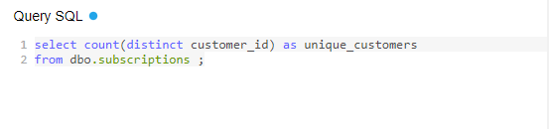

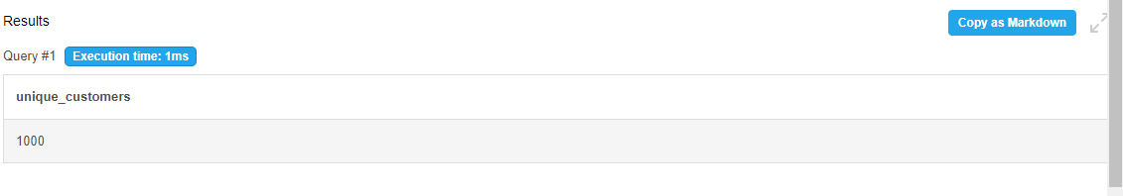

**Problem Statement - 2**

**What is the monthly distribution of trial plan start_date values for our dataset? — Use the start of the month as the**

**group by value.**

Solution - 2

SELECT

DATE_PART('month',start_date) AS month_date,

TO_CHAR(start_date, 'Month') AS month_name,

COUNT(*) AS trial_subscriptions

FROM dbo.subscriptions s

JOIN dbo.plans p

ON s.plan_id = p.plan_id

WHERE s.plan_id = 0

GROUP BY DATE_PART('month',start_date),

TO_CHAR(start_date, 'Month')

ORDER BY month_date ASC;

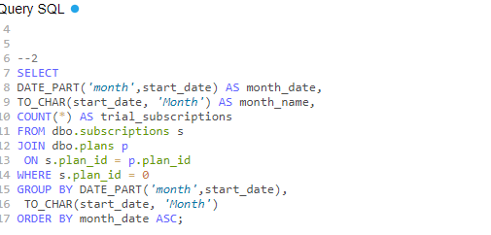

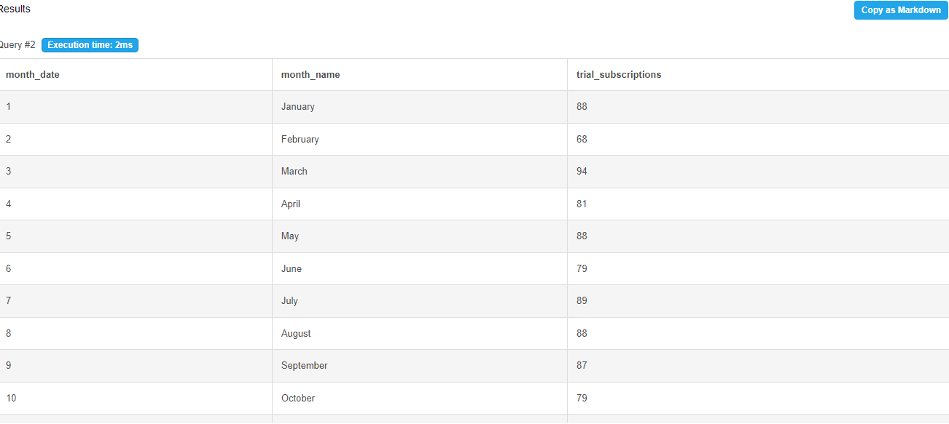

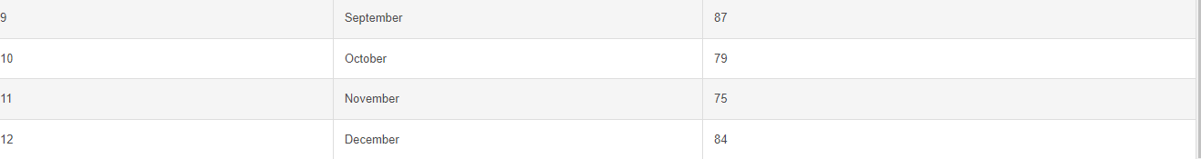

**Problem Statement - 3**

**What plan start_date values occur after the year 2020 for our dataset? Show the breakdown by count of events for**

**each plan_name.**

Solution - 3

SELECT

p.plan_id,

p.plan_name,

COUNT(*) AS events

FROM dbo.subscriptions s

JOIN dbo.plans p

ON s.plan_id = p.plan_id

WHERE s.start_date >= '2021-01-01'

GROUP BY p.plan_id, p.plan_name

ORDER BY p.plan_id;

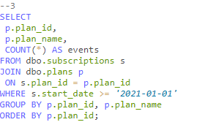

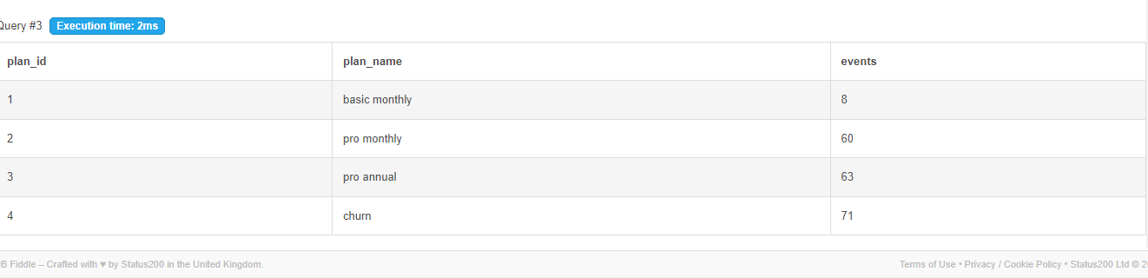

**Problem Statement - 4**

**What is the customer count and percentage of customers who have churned rounded to 1 decimal place?**

Solution - 4

SELECT

COUNT(*) AS churn_count,

ROUND(100 * COUNT(*)::NUMERIC / (

SELECT COUNT(DISTINCT customer_id)

FROM dbo.subscriptions),1) AS churn_percentage

FROM dbo.subscriptions s

JOIN dbo.plans p

ON s.plan_id = p.plan_id

WHERE s.plan_id = 4;

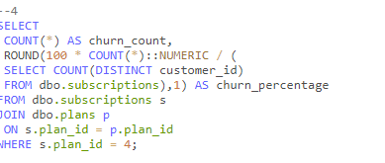

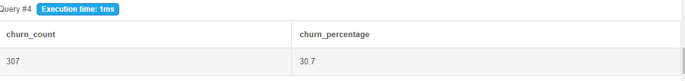

**Problem Statement - 5**

**How many customers have churned straight after their initial free trial? — what percentage is this rounded to the**

**nearest whole number?**

Solution - 5

WITH ranking AS (

SELECT

s.customer_id,

s.plan_id,

p.plan_name,

ROW_NUMBER() OVER (

PARTITION BY s.customer_id

ORDER BY s.plan_id) AS plan_rank

FROM dbo.subscriptions s

Solution - 5

JOIN dbo.plans p

ON s.plan_id = p.plan_id)

SELECT

COUNT(*) AS churn_count,

ROUND(100 * COUNT(*) / (

SELECT COUNT(DISTINCT customer_id)

FROM dbo.subscriptions),0) AS churn_percentage

FROM ranking

WHERE plan_id = 4 -- Filter to churn plan

AND plan_rank = 2

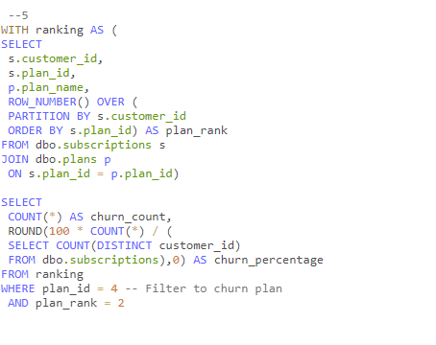

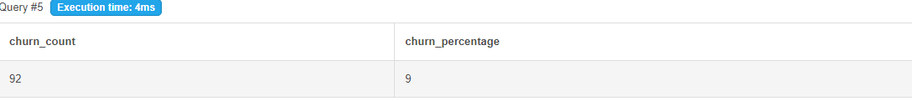

**Problem Statement - 6**

**What is the number and percentage of customer plans after their initial free trial?**

Solution - 6

WITH next_plan_cte AS (

SELECT

customer_id,

plan_id,

LEAD(plan_id, 1) OVER(

PARTITION BY customer_id

ORDER BY plan_id) as next_plan

FROM dbo.subscriptions)

Solution - 6

SELECT

next_plan,

COUNT(*) AS conversions,

ROUND(100 * COUNT(*)/ (

SELECT COUNT(DISTINCT customer_id)

FROM dbo.subscriptions),1) AS conversion_percentage

FROM next_plan_cte

WHERE next_plan IS NOT NULL

AND plan_id = 0

GROUP BY next_plan

ORDER BY next_plan;

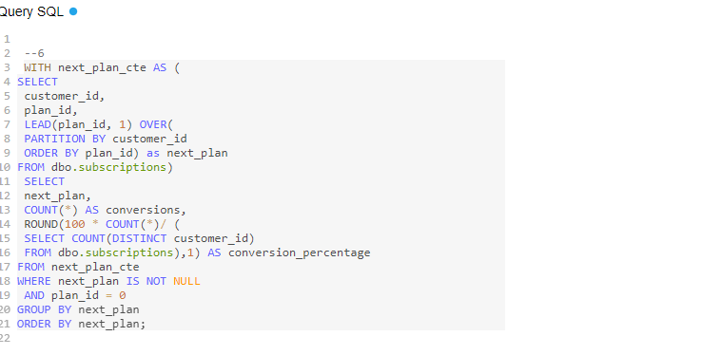

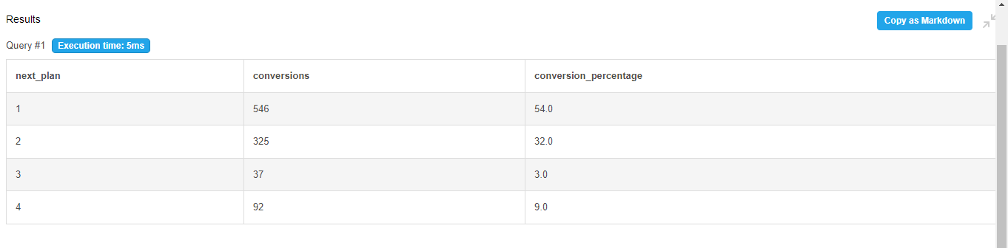

**Problem Statement - 7**

**What is the customer count and percentage breakdown of all 5 plan_name values at 2020–12–31?**

Solution - 7

WITH next_plan AS(

SELECT

customer_id,

plan_id,

start_date,

LEAD(start_date, 1) OVER(PARTITION BY customer_id ORDER BY start_date) as next_date

FROM dbo.subscriptions

WHERE start_date <= '2020-12-31'

),

Solution - 7

customer_breakdown AS (

SELECT

plan_id,

COUNT(DISTINCT customer_id) AS customers

FROM next_plan

WHERE

(next_date IS NOT NULL AND (start_date < '2020-12-31'

AND next_date > '2020-12-31'))

OR (next_date IS NULL AND start_date < '2020-12-31')

GROUP BY plan_id)

Solution - 7

SELECT plan_id, customers,

ROUND(100 * customers / (

SELECT COUNT(DISTINCT customer_id)

FROM dbo.subscriptions),1) AS percentage

FROM customer_breakdown

GROUP BY plan_id, customers

ORDER BY plan_id;

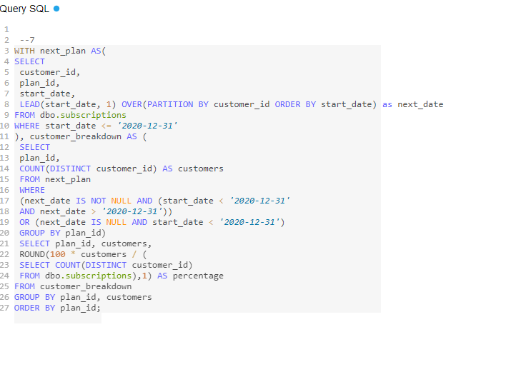

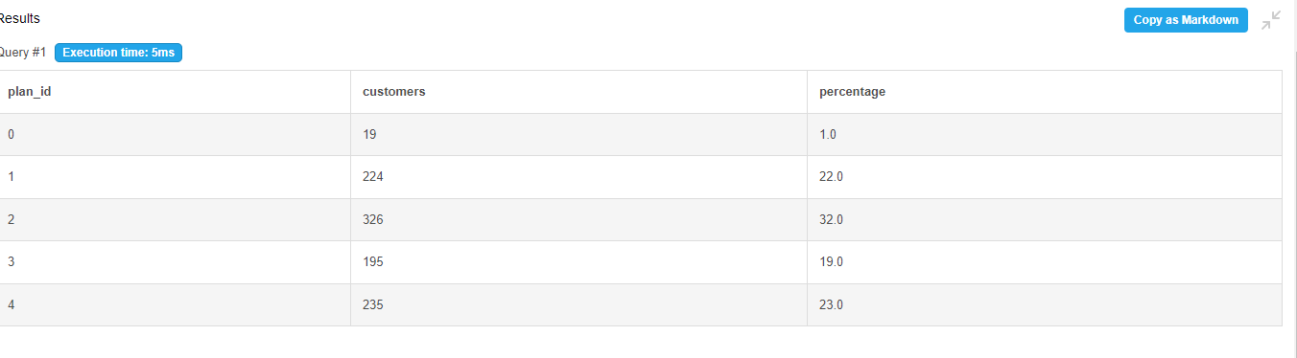

**Problem Statement - 8**

**How many customers have upgraded to an annual plan in 2020?**

Solution - 8

SELECT

COUNT(DISTINCT customer_id) AS unique_customer

FROM foodie_ﬁ.subscriptions

WHERE plan_id = 3

AND start_date <= '2020-12-31';

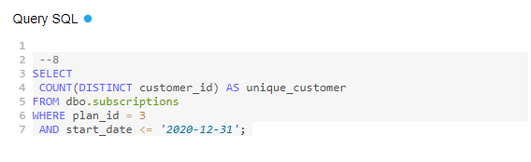

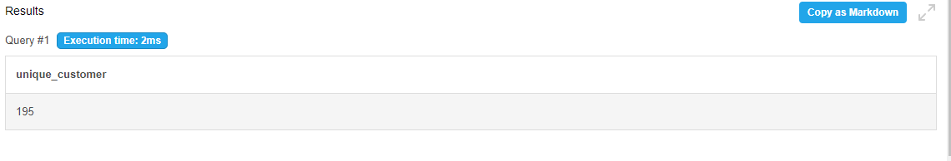

**Problem Statement - 9**

**How many days on average does it take a customer to an annual plan from the day they join Foodie-Fi?**

Solution - 9

-- Filter results to customers at trial plan = 0

WITH trial_plan AS

(SELECT

customer_id,

start_date AS trial_date

FROM dbo.subscriptions

WHERE plan_id = 0

),

-- Filter results to customers at pro annual plan = 3

annual_plan AS

Solution - 9

(SELECT

customer_id,

start_date AS annual_date

FROM dbo.subscriptions

WHERE plan_id = 3

)

SELECT

ROUND(AVG(annual_date - trial_date),0) AS avg_days_to_upgrade

FROM trial_plan tp

JOIN annual_plan ap

ON tp.customer_id = ap.customer_id;

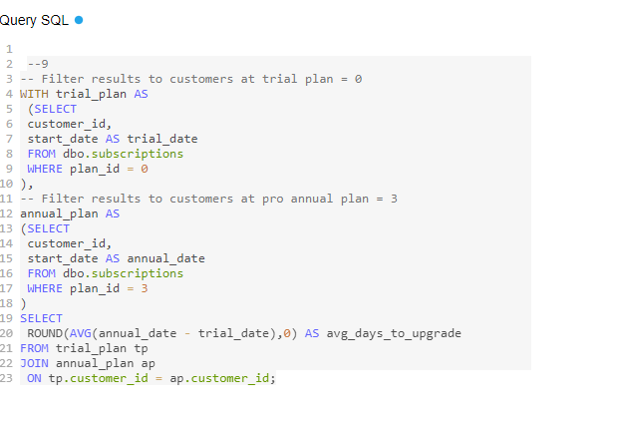

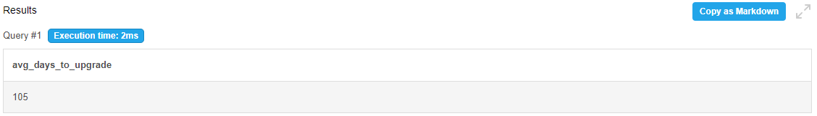

**Problem Statement - 10**

**Can you further breakdown this average value into 30-day periods? (i.e. 0–30 days, 31–60 days etc)**

Solution - 10

-- Filter results to customers at trial plan = 0

WITH trial_plan AS

(SELECT

customer_id,

start_date AS trial_date

FROM dbo.subscriptions

WHERE plan_id = 0

),

-- Filter results to customers at pro annual plan = 3

annual_plan AS

Solution - 10

(SELECT

customer_id,

start_date AS annual_date

FROM dbo.subscriptions

WHERE plan_id = 3

),

-- Sort values above in buckets of 12 with range of 30 days each

bins AS

(SELECT

WIDTH_BUCKET(ap.annual_date - tp.trial_date, 0, 360, 12) AS

avg_days_to_upgrade

FROM trial_plan tp

Solution - 10

JOIN annual_plan ap

ON tp.customer_id = ap.customer_id)

SELECT

((avg_days_to_upgrade - 1) * 30 || ' - ' || (avg_days_to_upgrade) * 30) || ' days' AS breakdown,

COUNT(*) AS customers

FROM bins

GROUP BY avg_days_to_upgrade

ORDER BY avg_days_to_upgrade

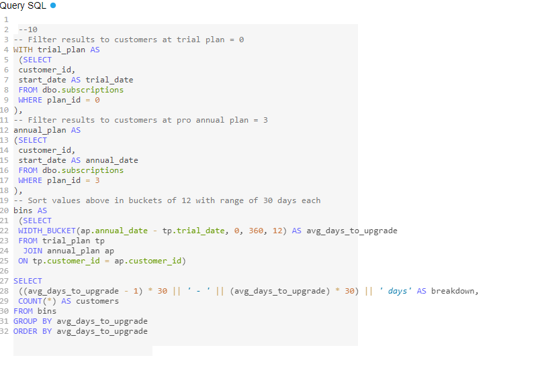

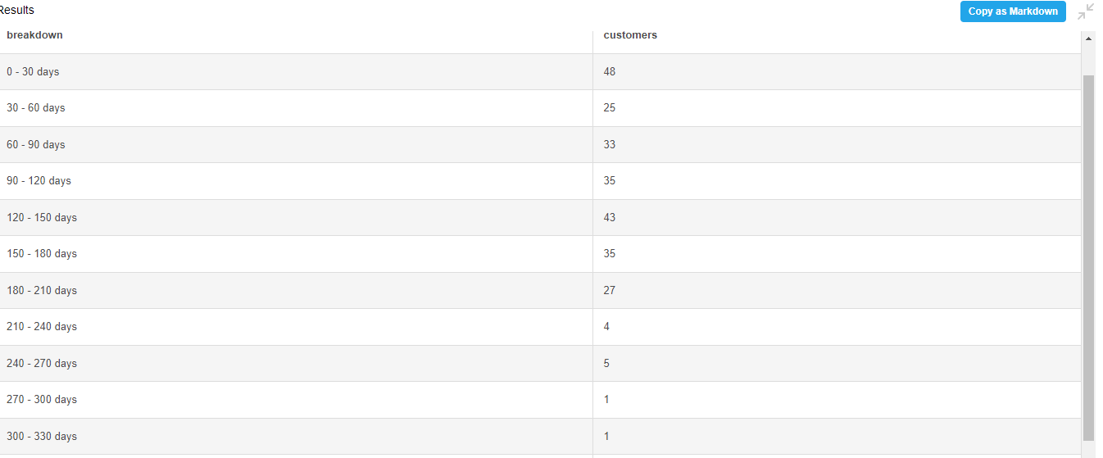

**Problem Statement - 11**

**How many customers downgraded from a pro-monthly to a basic monthly plan in 2020?**

Solution - 11

WITH next_plan_cte AS (

SELECT

customer_id,

plan_id,

start_date,

LEAD(plan_id, 1) OVER(

PARTITION BY customer_id

ORDER BY plan_id) as next_plan

FROM dbo.subscriptions)

Solution - 11

SELECT

COUNT(*) AS downgraded

FROM next_plan_cte

WHERE start_date <= '2020-12-31'

AND plan_id = 2

AND next_plan = 1;

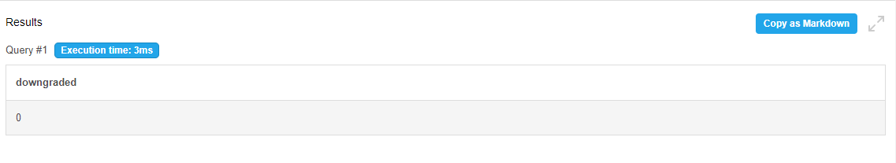

**Interpretation**

1. There are 1000 unique customers with Foodie Fie.
2. Month Of March had the highest subscription for trial plan , followed by May , July & August
3. After the year 2020 , churn was maximum (71 events)

Pro-annual plan had maximum subscription (63 events) , Pro-monthly had slightly lesser than Pro-annual (60 events) , Basic monthly had least (8 events) , where Trial wasn’t asked for.

1. Total customer count who have churned 307 & churn rate 30.7% ( not a very good figure for the company)
2. 92 customers have churned straight after free trail period , which is 9.2%( this much can be bearable).
3. Monthly basic plan had the highest conversion (from trial plan)
4. 195 customers upgraded to annual plan in 2020.
5. On an average it takes 105 days for customers to take annual plan from the day they join.
6. 0 customer downgraded from pro-annual to pro-monthly plan.

**Analysis & Conclusion**

* **Customer Journey**

There has been total of 1000 unique customers with the company , and the total churn rate was 30.7% . Expert says for B2C SaaS the average churn rate must be somewhere between 3-6% , above that is not a good sign . Here, for Foodie Fie it is 30.7% , they need to improve this figure(bring down) , some methods could be , first ,by adding some more value to their videos (by taking feedbacks & exploring new trends), second , could be bring down the price slightly lower.

* **Payments**

Considering 9.2% churned after trail period ,monthly plan had the highest conversion (54.6%) and 0 customer downgraded from pro-annual to pro-monthly plan bringing some stability in the payment.

* **Business Performance**

The business has been doing good in terms of retaining customers at pro-annual subscription , but not overall as the total churn rate is quite high for the business.

It needs to improve in retaining the customer overall. It will also be better if the conversion for pro-annual plan is the highest.